**The syntax and features**

The features are plus, minus, multiply, division, parentheses, modulo, hashtag, and, or, not, Equal to, Not equal to, Greater than, Less than, Greater than or equal to, Less than or equal to.

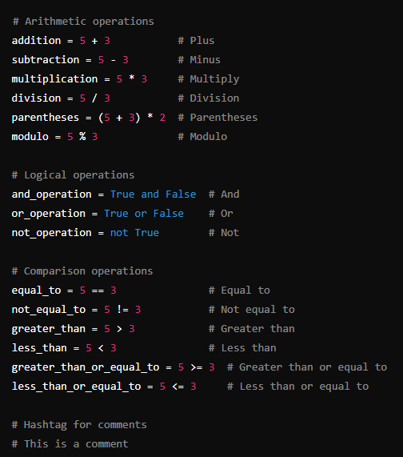

The syntax of our language is –

**Arithmetic Operations**

**Plus (+)**:

**Adds** two numbers together.

Example: 5 + 3 results in 8.

**Minus (-)**:

**Subtracts** the second number from the first.

Example: 5 - 3 results in 2.

**Multiply (*)**:

**Multiplies** two numbers together.

Example: 5 * 3 results in 15.

**Division (/)**:

**Divides** the first number by the second.

Example: 5 / 3 results in approximately 1.67.

**Parentheses (())**:

Used to **group expressions** and control the order of operations. Operations inside parentheses are performed first.

Example: (5 + 3) * 2 results in 16, while 5 + (3 * 2) results in 11.

**Modulo (%)**:

**Divides** the first number by the second and returns the **remainder**.

Example: 5 % 3 results in 2 (since 5 divided by 3 is 1 with a remainder of 2).

**Logical Operations**

**And**:

**Returns true** if **both conditions** are true.

Example: True and False returns False.

**Or**:

**Returns true** if **at least one condition** is true.

Example: True or False returns True.

**Not (!)**:

**Inverts the value** of the condition.

Example: not True returns False.

**Comparison Operations**

**Equal to (==)**:

**Checks if two values are equal**.

Example: 5 == 3 returns False.

**Not equal to (!=)**:

**Checks if two values are not equal**.

Example: 5 != 3 returns True.

**Greater than (>)**:

**Checks if the first value is greater** than the second.

Example: 5 > 3 returns True.

**Less than (<)**:

**Checks if the first value is less** than the second.

Example: 5 < 3 returns False.

**Greater than or equal to (>=)**:

**Checks if the first value is greater than or equal** to the second.

Example: 5 >= 3 returns True.

**Less than or equal to (<=)**:

**Checks if the first value is less than or equal** to the second.

Example: 5 <= 3 returns False.

**Hashtag (#)**:

**Marks a comment** in code, meaning the text following it will not be executed but serves as an explanation or documentation.

Example: # This is a comment in Python.